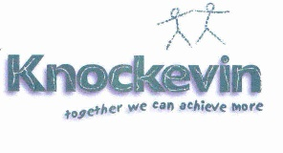
Knockevin School Newsletter
From school to home, keeping you informed
October 2021
Welcome back – we hope that you had a lovely half-term break. We loved seeing all the spooky costumes on our last day!  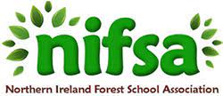  Outdoor Learning – as you may know from our social media posts, we were delighted to be awarded Forest School status. This award reflects the work we have done to develop outdoor learning. We continue to improve our provision outdoors and will keep you updated! We also congratulate our Eco Committee on their renewal of our Green Flag. They have done a lot of work to make our school more environmentally aware – well done!  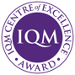  Inclusion Quality Mark – last term we were assessed for this award and we recently found out that not only did we achieve it but we have been awarded ‘Centre of Excellence’ status. We are now working as part of an IQM cluster group to further develop alongside other schools  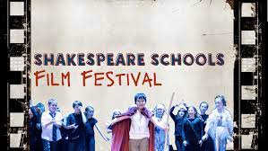  Shakespeare Stars – some of our pupils have been busy creating a film based on ‘A Midsummer Night’s Dream’. This will form part of the Shakespeare Schools Film Festival. Well done to all involved on their hard work so far – we can’t wait to see the finished version! | 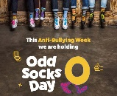  Anti-Bullying Week – this year anti-bullying week takes place from the 15th – 19th November. The theme is ‘One Kind Word’. We will be starting the week with ‘Odd Socks Day’ on Monday 15th and would encourage everyone to wear their odd socks to school that day!  Covid-19  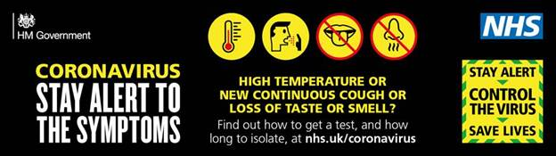  We continue to respond to the latest guidance and advice, while also carrying out our own risk assessments specific to our setting. We appreciate your understanding and support as we work hard to keep our pupils safe. Please be aware that staffing continues to be a challenge for us and unfortunately there may be times when we have to close class bubbles for health and safety reasons.  Please also remember that we have very vulnerable pupils in our school so do not send your child to school if they are unwell or have one or more of the symptoms of Covid-19:  -a new, continuous cough  -a high temperature/fever  -a loss or change to your sense of smell/taste  Important dates this Half-Term  Friday 19th Nov – Children in Need  Monday 15th Nov – Odd Socks Day  Friday 10th Dec – Christmas Jumper Day  Friday 17th Dec – last day of term, 12pm finish, non-uniform (back Tues 4th Jan 2022)
Contact us:
33 Racecourse Hill, Downpatrick, Co Down, BT30 6PU
Eyc – 46 Main Street, Dundrum, Co Down, BT33 0LY
Senior School – 2 Church Street, Castlewellan
02844612167 / 02843751788 / 02843444200
knockevinschool.co.uk
Find us at facebook.com/knockevin and @knockevin on Twitter

